***Faculty of Computing & Information Technology***

**CC-215-L: Database Systems Lab**

**BSCS Morning - Fall 2022, Semester Spring 2024**

**LAB – 03**

**Lab Instructor**: Sanam Ahmad

**Topics**

1. Single Row Functions
2. Upper, Lower
3. Left, Right
4. Pad, Trim
5. Length, Reverse
6. Replace

***Allowed time: 90 mins.***

***Instructions:***

1. Gossips are not allowed.
2. Teacher assistants are for your help, so be nice with them. Respect them as they are teaching you. Raise your hands if you have some problem and need help from TA. Avoid calling them by raising your voice and disturbing the environment of Lab.
3. TA may deduct your marks for any kind of ill-discipline or misconduct from your side.
4. Evaluation will be considered final and you cannot debate for the marks. So, focus on performing the tasks when the time is given to you.
5. Paste the query as well as result table screenshot as a result of each task

**Task 01: _________________________ (8 Marks)**

1. Find the occurrence of letter ‘M’ in Job and display if it is greater than 0.
2. Remove the left and right spaces from the string “ I Love Pakistan ”
3. In this string “ I Love Pakistan ” Replace "Pakistan" with "Country", remove leading and trailing spaces, and extract the entire modified string.

**End output: “I Love Country”**

1. 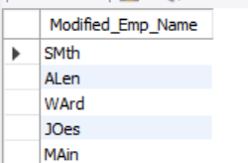Display the name of emp that contain first 2character uppercase and last 2 character lower case.
2. Extract the first 3 characters of the JOB field, add of job length “*” on the left side and add “– “ on Right side, and reverse the extracted portion of the job.

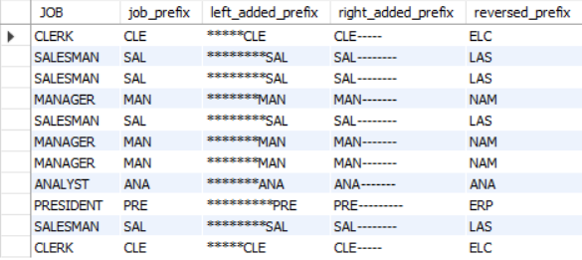

1. Display those employees whose concatenated salary and employee number(empno) has an odd length.
2. Retrieve the salary (SAL), job title (JOB), and employee name (ENAME) from the "EMP" table. If the salary is greater than 2500, the job title is "MANAGER", and the number of characters in the employee's name (after removing all occurrences of the letter 'A') is even, the employee's name will be displayed in uppercase; otherwise, it will be displayed in lowercase.

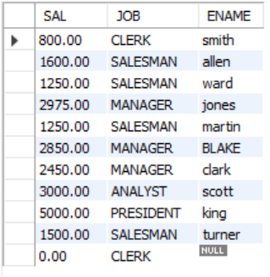

1. Write a SQL query to retrieve the employee name (ENAME) and job title (JOB) from the EMP table. In the job title, replace the first character of the employee's name with the second character of their name. Display the employee name, job title, and the modified job title as "MODIFIED_JOB."

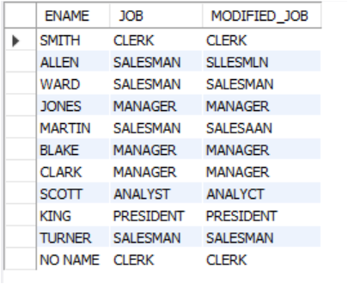

### ****Task 2 (14 Marks)****

1. List all the employee whose length of salary is divisible by 4( . and onward not include as length count) and hired in leap year.
2. Retrieve the employee name (ENAME), job title (JOB), and a string displaying the total length of the employee name (or "ANONYMOUS" if the name is NULL) and the job title combined, followed by a hyphen, and the length of the job title with all occurrences of the letters 'A' and 'E' removed from the "EMP" table.

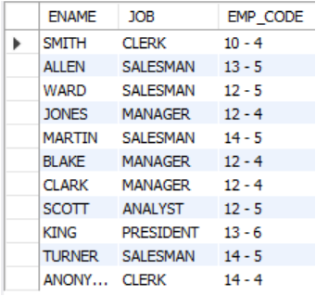

1. Count the number of occurrences of vowel letters and consonant letters in the concatenated ENAME and JOB fields.

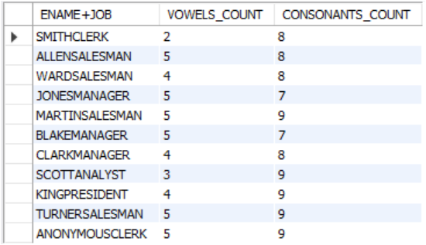

1. Write a query that performs the following operations on the ENAME field from the EMP table
   1. Extract the part of the employee name that comes before the first occurrence of the letter .
   2. Calculate the total length of the employee name.
   3. Replace all occurrences of the letter 'I' in the employee name with the '@' symbol.
   4. Extract the first 3 letters of the employee name.
   5. Extract the last 2 letters of the employee name.
   6. Create a shortened job title by combining the first 3 characters and the last 3 characters of the job title, with '...' in between. Apply filter where Length of employee name is greater than 4.
2. Display ename , empno , Job , “Modified Column” that replace the first 3 character of ename with the last 3 job characters and pad the characters of job with # . Count of # on each side should be equal to the last number in empno.

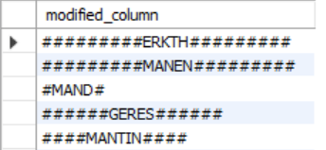

1. Write a query:
2. For each employee, print 'ghost' if ename is null, otherwise display the actual ename.
3. Add the sal column with 'X' on the right if the salary is greater than 3000, otherwise add with 'Y' on the left until it is 8 characters long.
4. Modify ename to lowercase if it contains the letter 'O', otherwise display it in uppercase. If ename is null, display ghost.
5. Generate an email for each employee in the format [name@gmail.com](mailto:name@gmail.com)
6. Write a query that **Calculates the tax** for each employee based on their salary **Tax brackets**:
   1. Salary up to 2000: 5% tax
   2. Salary between 2001 and 4000: 10% tax
   3. Salary above 4000: 15% tax

**Displays the final salary** after deducting the calculated tax.

Display the employee’s name and job title, formatted as Ename(JOB) eg. **Smith(Clerk)**

****Task 3 11 Marks****

1. Write a query that performs the following operations
   1. For each employee, pad the (salary) column with leading zeros until it is 6 digits long. If the salary is missing (NULL), display 'N/A' instead.
   2. For the (commission) column, the value with '*' until it is 4 characters long. If the commission is missing (NULL), display 'N/A' instead.
   3. Calculate the length of the salary column
   4. Concatenate a statement that includes the employee's uppercase ename, the salary (where all zeros are replaced with '#'), and the phrase "per month." The number of “#” that added on left side of salary is determined by the combined length of the employee's job title and ename.
   5. Also apply the filter of salary greater than thousand.

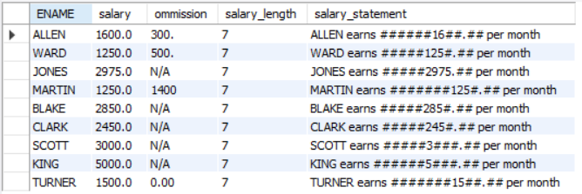

1. Write a SQL query to retrieve the exact same output.

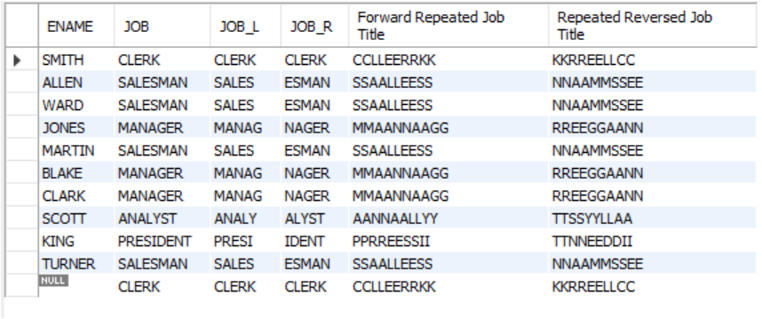

1. Write a query that performs the following operations: **(5 Marks)**
2. **For each employee, add the** * **on both sides of ename**, the count of * should equal to the vowels count in the ename .
3. **Extract and reverse the middle part of the** ename.
4. For the job column, replace all vowels with the '@' symbol.

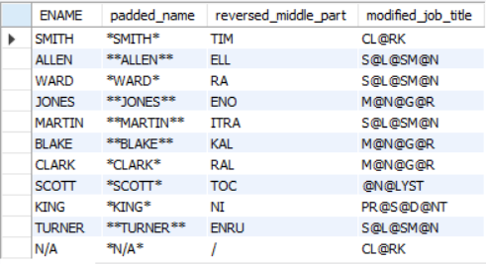

****VIVA Voce 3 Marks****